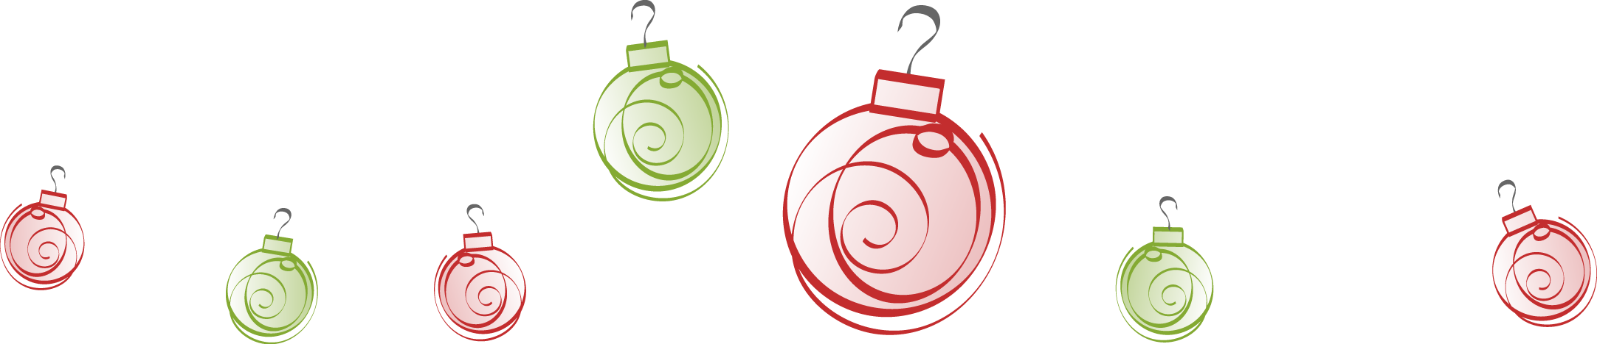

Dear Customer,
Our office hours over the Christmas period are as follows:
The company will be closed from
Friday 23rd December at 12:30pm
and will re-open in 2023
Tuesday 3rd January at 8:30am

The Management and Staff of LanganBach Services would like to take this opportunity to thank all of our Customers and Suppliers for supporting us throughout the year.
We wish you a very happy and safe Christmas.
&
All the very best for the New Year!
